TASK-2

TITLE: Design a 4-stage pipelined processor with basic instruction like ADD, SUB and LOAD
OBJECTIVE: 1. To design a basic 4-stage pipelined processor
2. To implement arithmetic and load instructions
3. To understand instruction-level parallelism
4. To simulate stage-by-stage execution using Verilog HDL
SOFTWARE USED: vivado
PIPELINE ARCHITECTURE:
The processor contains 4 stages:
Stage | Name | Function
Stage-1 | Instruction fetch (IF) | Fetch instruction from memory
Stage-2 | Instruction decode (ID) | Decode instruction and read registers
Stage-3 | Execute (Ex) | Perform ALU operations
Stage-4 | Write Back (WB) | Store results into register
Supported instructions:
Instruction | Operation
ADD | Addition of two operands
SUB | subtraction of two operands
LOAD | Load data into register

CODE:
VERILOG CODE FOR PIPELINE PROCESSOR:
`timescale 1ns / 1ps
///pineline processor design
module ppd(
input clk,
input reset
);
reg [7:0] regfile [0:7];
reg [15:0] instr_mem [0:15];
reg [7:0] data_mem [0:15];
reg [3:0] pc;
reg [15:0] if_id_instr;
reg [3:0] id_ex_opcode;
reg [3:0] id_ex_rd;
reg [7:0] id_ex_data1;
reg [7:0] id_ex_data2;
reg [3:0] ex_wb_rd;
reg [7:0] ex_wb_result;
integer i;
parameter ADD = 4'b0001;
parameter SUB = 4'b0010;
parameter LOAD = 4'b0011;
initial begin
regfile[0] = 8'd0;
regfile[1] = 8'd10;
regfile[2] = 8'd5;
regfile[3] = 8'd2;
regfile[4] = 8'd8;
regfile[5] = 8'd4;
regfile[6] = 8'd0;
regfile[7] = 8'd0;
data_mem[0] = 8'd25;
data_mem[1] = 8'd50;
instr_mem[0] = {ADD, 4'd0, 4'd1, 4'd2};
instr_mem[1] = {SUB, 4'd3, 4'd4, 4'd5};
instr_mem[2] = {LOAD, 4'd6, 4'd0, 4'd1};
end
always @(posedge clk or posedge reset)
begin
if(reset)
begin
pc <= 0;
if_id_instr <= 0;
id_ex_opcode <= 0;
id_ex_rd <= 0;
id_ex_data1 <= 0;
id_ex_data2 <= 0;
ex_wb_rd <= 0;
ex_wb_result <= 0;
end
else
begin
regfile[ex_wb_rd] <= ex_wb_result;
case(id_ex_opcode)
ADD:
begin
ex_wb_result <= id_ex_data1 + id_ex_data2;
ex_wb_rd <= id_ex_rd;
end
SUB:
begin
ex_wb_result <= id_ex_data1 - id_ex_data2;
ex_wb_rd <= id_ex_rd;
end
LOAD:
begin
ex_wb_result <= data_mem[id_ex_data2];
ex_wb_rd <= id_ex_rd;
end
default:
begin
ex_wb_result <= 0;
ex_wb_rd <= 0;
end
endcase
id_ex_opcode <= if_id_instr[15:12];
id_ex_rd <= if_id_instr[11:8];
id_ex_data1 <= regfile[if_id_instr[7:4]];
id_ex_data2 <= if_id_instr[3:0];
if_id_instr <= instr_mem[pc];
pc <= pc + 1;
end
end
endmodule

TESTBENCH FOR THAT VERILOG CODE:
`timescale 1ns / 1ps
///testbench for the pipeline processor
module ppd_tb;
reg clk;
reg reset;
ppd uut(
.clk(clk),
.reset(reset)
);
always #5 clk = ~clk;
initial
begin
clk = 0;
reset = 1;
#10;
reset = 0;
#100;
$finish;
end
initial
begin
$monitor("TIME=%0t | PC=%d | R0=%d | R3=%d | R6=%d",
$time,
uut.pc,
uut.regfile[0],
uut.regfile[3],
uut.regfile[6]);
end
endmodule

PRACTICAL OUTPUT:
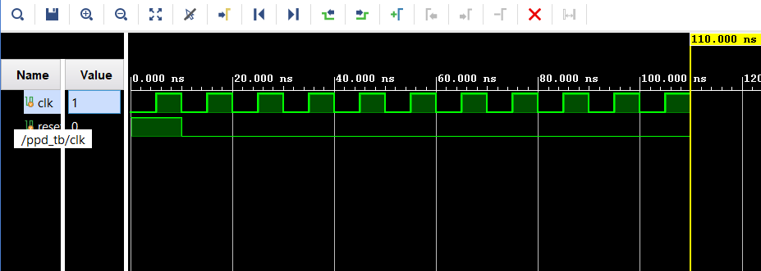
CONCLUSION:
The 4-stage pipelined processor was successfully designed and simulated using veilog HDL. The processor correctly execute ADD, SUB, an LOAD instructions through IF, ID, EX, and WB stages

